|  |  |
| --- | --- |
| ***D:\seminar\KIIT_logo.svg.png* School of Computer Engineering**  **KIIT Deemed to be University** |  |

**Java Programming Laboratory Lesson Plan**

**Spring 2024-25 (4th Semester)**

Discipline : CSE

Course name and Code : Java Programming Laboratory(CS29004)

L-T-P-Cr : 0-0-2-1

Instructor Name : Mr. Pradeep Kandula, [Email: pkandulafcs@kiit.ac.in](mailto:Email:%20manas.nayakfcs@kiit.ac.in)

Instructor Chamber : FB-101, Block-C, Campus-14

Technical Assistants Names: TA-1(Name, email, contact no)

TA-2(Name, email, contact no)

**Course Outcomes:**

Upon completion of this course, the students will be able to:

CO1: Run java programs using java compiler/IDE

CO2: Write java programs using basic object oriented programming concepts

CO3: Write programs using abstract classes interfaces and packages

CO4: Write java program using multi-threading and exception handling

CO5: Design Java application using String and I/O classes

CO6: Design GUI application using Swing and interactive application using event handling and JDBC

**List of Experiments (Day wise):**

**Lab 1 - Course Contents:**

**-**Writing compiling and executing a simple Java programs

**List of Programs :**

1. ***Aim of the program -***Write a program to print your name, roll no, section and branch in separate lines.

***Input*:** Mention Name,Roll no,Section and branch

***Output*:**  Display Name

Display Roll No

Display Section

Display Branch

1. ***Aim of the program:*** Write a program to print the corresponding grade for the given mark using if..else statement in Java

***Input:***Mention the grade in the program

***Output*:** Display the Grade either O/E/A/B/C

1. ***Aim of the program:***  Write a program to print the week day for the given day no. of the current month using switch case statement

***Input*:** Mention the Day no in the program

***Output*:** Display the week day(either Sunday/Monday/Tuesday/Wednesday /Thursday/Friday/Saturday)

1. ***Aim of the program :*** Program to check a user entered number is palindrome or not

***Input*:** Mention the number in the program

***Output*:** display the number is Palindrome or not.

1. ***Aim of the program :*** Write a program in Java to take first name and last name from user and print both in one line as last name followed by first name

***Input:*** Enter first name: KIIT

Enter Second Name: UNIVERSITY

***Output*:** UNIVERSITY KIIT

**Lab 2 - Course Contents: -** Array in Java

- Command line arguments in Java, Scanner Class

- static modifier in Java

**List of Programs :**

1. ***Aim of the program :*** Find the largest among 3 user entered nos. at the command prompt using Java

***Input:*** Enter three number .

***Output:*** Display the Largest Number

1. ***Aim of the program :*** Accept 10 numbers from command line and check how many of them are even and how many are odd.

***Input:*** Enter 10 number from keyboard

***Output:*** Display number of even and odd number

1. ***Aim of the program:*** Program to sort the user entered list of numbers of any size

**Input:** List of Numbers

**Output:** Display the numbers in Ascending order

1. ***Aim of the program:*** Program to find no. of objects created out of a class using ‘static’ modifier.

***Input:*** No of objects created

***Output:*** Display the number of objects created (e.g. no of objects=3)

1. ***Aim of the program:*** Find the no. of occurrence of each element in a user entered list of nos.

***Input:*** Enter list of numbers e.g.( 15 25 15 11 25 32 15 32)

***Output:*** Occurrence of 15=3

Occurrence of 25=2

Occurrence of 11=1

Occurrence of 32=2

1. ***Aim of the program:***  Find sum of each diagonal (left & right) elements separately of a user entered 3 X 3 matrix in Java.

***Input:*** Enter 3X3 matrix

e.g. 6 7 3

8 9 2

1 2 9

***Output:*** Left=24

Right=13

**Lab 3 - Course Contents: -**class and objects in Java

*-*method overloading in Java

-constructor overloading in Java

**List of Programs :**

1. ***Aim of the program :***Write a class file – box with three data members(length, width, height) and a method volume() . Also implement the application class Demo where an object of the box class is created with user entered dimensions and volume is printed.

***Input:*** length,width and height.

***Output:*** Volume

1. ***Aim of the program :*** Write a program in Java to create a class Rectangle having data members length and breadth and three methods called read, calculate and display to read the values of length and breadth, calculate the area and perimeter of the rectangle and display the result respectively.

Create a class named 'Rectangle' with two data members 'length' and 'breadth' and

two methods to print the area and perimeter of the rectangle respectively.

Its constructor having parameters for length and breadth is used to initialize length

and breadth of the rectangle.

Create a class named 'Rectangle' with two data members 'length' and 'breadth' and

two methods to print the area and perimeter of the rectangle respectively.

Its constructor having parameters for length and breadth is used to initialize length

and breadth of the rectangle.

***Input:*** Mention length and breadth

***Output:***Display Area of Rectangle and Perimeter of rectangle.

1. ***Aim of the program :***  Write a program in java to input and display the details of n number of students having roll, name and cgpa as data members. Also display the name of the student having lowest cgpa.

***Input:*** Enter Roll No, Name and cgpa of ‘n’ number of students.

***Output:*** Display the details of ‘n’ number of students. Also display the name of student with lowest cgpa

1. ***Aim of the program :*** Write a program to overload subtract method with various parameters in a class in Java. Write the driver class to use the different subtract methods using object.

***Input:*** Mention various subtract method having different parameters.

***Output:*** Subtract method will display the result accordingly

1. ***Aim of the program :*** Write a program which will overload the area () method and display the area of a circle, triangle and square as per user choice and user entered dimensions.

***Input:*** Mention dimensions like radius, base, height, side

***Output:*** Display area of circle

Display area of triangle

Display area of square

1. ***Aim of the program :*** Write a program in java using constructor overloading concept to calculate the area of a rectangle having data member as length and breadth. Use default constructor to initialize the value of the data member to zero and parameterized constructor to initialize the value of data member according to the user input.

***Input:*** Mention the value of length and breadth

***Output:***Display the area of rectangle accordingly.

**Lab 4 - Course Contents:** -Single level inheritance in Java

-Multi-level inheritance in Java

- Method Overriding and use of final and super keyword in java

- Dynamic Method Dispatch

**List of Programs :**

1. ***Aim of the program :*** A Plastic manufacturer sells plastic in different shapes like 2D sheet and 3D box. The cost of sheet is Rs 40/ per square ft. and the cost of box is Rs 60/ per cubic ft. Implement it in Java to calculate the cost of plastic as per the dimensions given by the user where 3D inherits from 2D.

***Input:*** Enter dimensions

***Output:*** Display the cost of plastic

1. ***Aim of the program :*** Illustrate the execution of constructors in multi-level inheritance with three Java classes – plate(length, width), box(length, width, height), wood box (length, width, height, thick) where box inherits from plate and woodbox inherits from box class. Each class has constructor where dimensions are taken from user.

***Input:*** Enter the dimensions

***Output:*** Display the dimensions accordingly

1. ***Aim of the program :*** Write a program in Java having three classes Apple, Banana and Cherry. Class Banana and Cherry are inherited from class Apple and each class have their own member function show() . Using Dynamic Method Dispatch concept display all the show() method of each class.

***Input****:*  Mention show function of each class.

***Output****:* Display show function of each class accordingly.

1. ***Aim of the program :*Write** a class Account containing acc\_no, balance as data members and two methods as input() for taking input from user and disp() method to display the details. Create a subclass Person which has name and aadhar\_no as extra data members and override disp() function. Write the complete program to take and print details of three persons.

***Input:*** Enter details of three persons.

***Output:***Display details of three persons.

**Lab 5 - Course Contents:** – Abstract class in Java

– Interface in Java

**-** Package in Java

**List of Programs :**

1. ***Aim of the program*** -Illustrate the usage of abstract class with following Java classes –

* An abstract class ‘student’ with two data members roll no, reg no, a method getinput() and an abstract method course()
* A subclass ‘kiitian’ with course() method implementation

Write the driver class to print the all details of a kiitian object.

***Input*** - Rollno - 2205180

Registration no - 1234567890

***Output*** -Rollno - 2205180

Registration no - 1234567890

Course - B.Tech. (Computer Science & Engg)

1. ***Aim of the program*** *-*Define an interface Motor with a data member –capacity and two methods such as run() and consume(). Define a Java class ‘Washing machine’ which implements this interface and write the code to check the value of the interface data member thru an object of the class.

***Input***- mentioned in the program

***Output*** - Capacity of the motor is -----

1. ***Aim of the program*** *-*Define an interface with three methods – earnings(), deductions() and bonus() and define a Java class ‘Manager’ which uses this interface without implementing bonus() method. Also define another Java class ‘Substaff’ which extends from ‘Manager’ class and implements bonus() method. Write the complete program to find out earnings, deduction and bonus of a substaff with basic salary amount entered by the user as per the following guidelines –

earnings basic + DA (80% of basic) + HRA (15% of basic)

deduction PF 12% of basic

bonus 50% of basic

***Input*** *-*Basic salary - 50000

***Output***-Earnings - 97500

Deduction -6000

Bonus - 25000

1. ***Aim of the program*** *-* Define an interface Emploee with a method getDetails() to get emplyee details as Empid and Ename. Also define a derived interface Manager with a method getDeptDetails() to get department details such as Deptid and Deptname.Then define a class Head which implements Manager interface and also prints all details of the employee. Write the complete program to display all details of one head of the department.

***Input*** - Enter employee id - 123

Enter employee name - Sidharth Ambani

Enter department id - 06

Enter department name -Marketing

***Output***- Employee id - 123

Employee name - Sidharth Ambani

Department id - 06

Department name -Marketing

1. ***Aim of the program -*** Define two packages as – General and Marketing. In General package define a class ‘employee’ with data members as empid(protected), ename(private) and a public method as earnings() which calculate total earnings as

earnings basic + DA (80% of basic) + HRA (15% of basic)

In Marketing package define a class ‘sales’ which is extending from ‘employee’ class and has a method tallowance() which calculates Travelling Allowance as 5% of total earning. Write the programs to find out total earning of a sales person for the given basic salary amount and print along with the emp id.

***Input:*** Enter the employee id and emploee name 123 Amit

Enter the basic salary 1000

***Output:*** The emp id of the employee is 123

The total earning is 1950.0

**Lab 6 - Course Contents: -**  Exception handling in Java

- User defined exception in Java

**List of Programs :**

1. ***Aim of the program -*** Write a Java program to generate an ArrayIndexOutofBoundsException and handle it using catch statement.

***Input:*** Enter the numbers -Example: 1 2 3 4 5 ( Suppose array size is 4 )

***Output:***Exception in thread “main” java.lang.ArrayIndexOutOfBoundsException:4

1. ***Aim of the program-*** Write a Java program to handle an ArithmeticException using try, catch, and finally block.

***Input:*** Operand values for division operation mentioned in the program

***Output:*** ArithmeticException caught by try-catch-finally block

1. ***Aim of the program-*** Write a Java class which has a method called ProcessInput(). This method checks the number entered by the user. If the entered number is negative then throw an user defined exception called NegativeNumberException, otherwise it displays the double value of the entered number.

***Input:*** Enter a number 4

***Output:*** Double value: 8

***Input:*** Enter a number -4

***Output:*** Caught the exception

Exception occurred: NegativeNumberException: number should be positive

1. ***Aim of the Program:*** Write a program to create user defined exceptions called HrsException, MinException and SecException. Create a class Time which contains data members hours, minutes, seconds and a method to take a time from user which throws the user defined exceptions if hours (>24 &<0),minutes(>60 &<0),seconds(>60 &<0).

***Input:*** Enter hours: 4

Enter minutes: 54

Enter seconds: 34

***Output:*** Correct Time-> 4:54:34

***Input:*** Enter hours: 30

Enter minutes: 65

Enter seconds: 65

***Output:*** Caught the exception

Exception occurred: InvalidHourException:hour is not greater than 24

Exception occurred: InvalidMinuteException:hour is not greater than 60

Exception occurred: InvalidSecondException:hour is not greater than 60

1. ***Aim of the Program:*** Create an user defined exception named CheckArgument to check the number of arguments passed through command line. If the number of arguments is less than four then throw the Check Argument exception, else print the addition of squares of all the four elements.

***Input:*** 4 3 2 1

***Output :*** 30

***Input:*** 4 3 2

***Output :*** Exception occurred - CheckArgument

**Lab 7 - Course Contents:** - String handling in Java

**-** File Handling in Java

**List of Programs :**

1. ***Aim of the program -***Write a program to perform following operations on user entered strings and a character –
2. Change the case of the string
3. Reverse the string
4. Compare two strings
5. Insert one string into another string
6. Convert the string to upper case and lower case
7. Check whether the character is present in the string and at which position
8. Check whether the string is palindrome or not.
9. Check the number of word, vowel and consonant in the string

***Input:*** Enter a String : amit

***Output:*** The string after changing the case is AMIT

The string after reversing is tima

***Input:*** Enter the second string for comparision : kumar

***Output:*** The difference between ASCII value is 10

***Input:*** Enter the string to be inserted into first string : thakur

***Output:*** The string after insertion is : amit thakur

***Input:***Enter a String : Amit

***Output:*** Uppercase: AMIT

Lowercase: amit

***Input:*** Enter a String :Amitkumar

Enter a character : m

***Output:*** Position of entered character: 2

***Input:*** Enter a String : Amitkumar

Enter a character : Y

***Output:*** Entered character is not present

***Input:***Enter a String : madam

***Output:*** Entered string is palindrome

***Input:*** Enter a String : muscle

***Output:*** Entered string is not a palindrome

***Input:*** Enter a String : Ram is going to school

***Output:*** No. of words: 5

No. of vowels: 7

No. of consonants: 11

1. ***Aim of the program -*** Write a java program which will accept students details like Student RollNo, Name, Subject, Marks from the keyboard using scanner class, stored the same in a file. Again open the file, read the content and display all.

***Input:*** Enter student details - Rollno, name, subject, marks

Enter the name of existing file to which student details will be written.

***Output:*** Display the content of existing file

1. ***Aim of the program -*** Write a program in Java to copy the content of a given file to another user entered file using character stream (using File Reader and FileWriter Classes) and byte Stream (using FileInputStream and FileOutputStream Class).

***Input:*** Enter the source file name - sourcefile.txt (Assume Input file exists in the system)

Enter the destination file name - destinationfile.txt

***Output:*** File Copied

1. ***Aim of the program -***Write a java program to compare two binary files, printing the first byte position where they differ.

***Input:*** Specify two binary files in the program (Assume two files are exist in the system)

***Output:*** Two files are equal

***Input:*** Specify two binary files in the program

***Output:*** Two files are not equal: byte position at which two files differ is 30

1. ***Aim of the program -***Write a java program that displays the number of characters, no. of lines and no. of words present in a text file whose name is given by the user.

***Input:*** Name of the file - filename

***Output:*** No. of characters - A,

No .of lines - B

No . of words - C

**Lab 8 - Course Contents: -** Multi-threading in Java

**List of Programs :**

1. ***Aim of the program -*** Write a program in Java using multi-threading which will display a counter value within a specified range with a gap of 5 milliseconds after setting it’s name as given by the user.

***Input :*** Name of the thread - First

Lower range of counter - 10

Upper range of counter - 15

***Output :*** Thread - First

Counter - 10 11 12 13 14 15

1. ***Aim of the program -***Write a program in java which will display the working of two threads in synchronization.

***Input:***

***Output:***

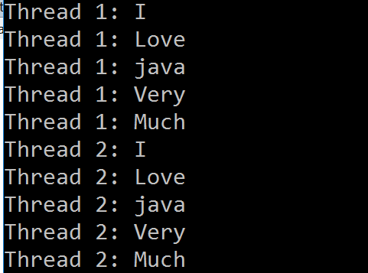

1. ***Aim of the program -***Design a Stop Watch using event handling and multi-threading in Java.

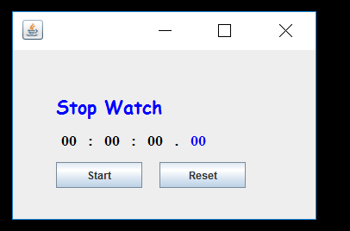

**Practice Program Sets**:-

1. ***Aim of the program -*** Design a swing application using event and multithreading which will display multiple images one after another moving in a square shape with a gap of 10 millisecond. At the same time, four messages like - " Welcome "," Enjoy "," Thanks "," Visit Again " will also be displayed one after another on the same page.

***Output*:** Animation of images

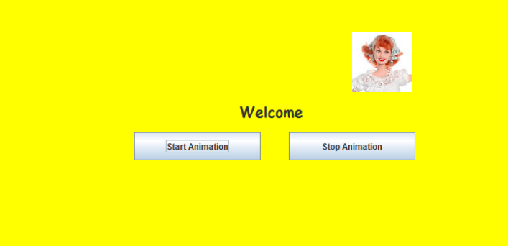

**Lab 9- Course Contents:** – Java Database Connectivity

**List of Programs :**

1. ***Aim of the program*** -Write a java program which will display all the records from the student table.

***Input***: Table name mentioned in the program

|  |  |  |
| --- | --- | --- |
| 2205123 | rakesh yadav | 76 |
| 2205230 | sanjiv kumar | 82 |
| 2206345 | pranab dutta | 73 |
| 2206242 | asish mukherjee | 78 |
| 2205542 | suman singh | 85 |

***Output*** :

1. ***Aim of the program*** - Write a java program which will display a particular record from the student table on the basis of RollNo supplied from the keyboard.

***Input*** : Rollno (2205542)

|  |  |  |
| --- | --- | --- |
| 2205542 | suman singh | 85 |

***Output***:

1. ***Aim of the program*** - Write a java program which will insert a record, update and delete a particular record in the student table.

***Input***: Enter rollno to be inserted : 2205650

Enter name : Aditya Bajaj

Enter marks : 93

***Output*** : 1 record inserted

1. ***Aim of the program***-Write a java program which will display all the records from the student table along with the column heading.

***Input*** :Table name mentioned in the program

|  |  |  |
| --- | --- | --- |
| Roll no | Name | Marks |
| 2205123 | rakesh yadav | 76 |
| 2205230 | sanjiv kumar | 82 |
| 2206345 | pranab dutta | 73 |
| 2206242 | asish mukherjee | 78 |
| 2205542 | suman singh | 85 |

***Output*** *:*

1. ***Aim of the program*** -Design an interface as shown below using Frame and Swing in Java

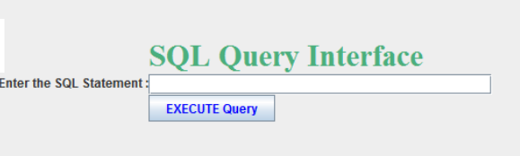

Here the user will write a query in the text field and then click on the execute query button. The output of the query will be displayed on another hidden text area.

***Input***: select mark from student where rollno= 2205230

***Output*** : 82

**Practice Program Sets**:-

***Aim of the program***-Design an interface as shown below using Frame and Swing in Java .

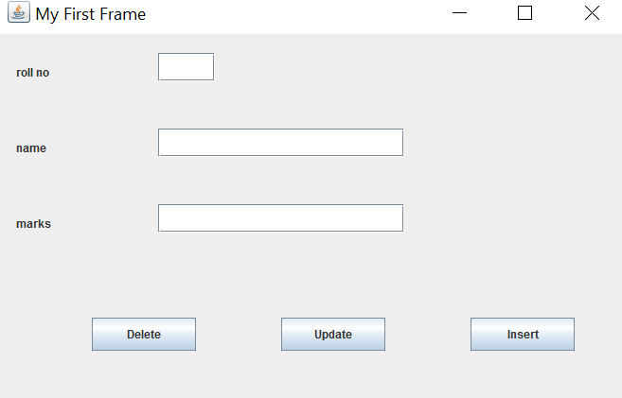

The user will fill up the details and after clicking on the insert button, the data will be inserted in the table. Similarly Update button will update the record based on the Roll No and in the same way delete button will delete the corresponding record from the table.

***Input :*** Rollno - 2205423

Name - Manish Malhotra

Marks - 84

***Outpu****t* : On clicking Insert button - one record inserted

On clicking Update button - one record updated

On clicking Delete button - one record deleted

**Lab 10 - Course Contents:** – GUI Programming using Swing in Java

– Event Handling in Java

**List of Programs :**

1. ***Aim of the program*** *-*Design a registration form using Swing with following components on it – Label, Textbox, Text area, Checkbox, Radio button and Button, Image.
2. ***Aim of the program*** *-*Write a GUI program in Java with three Labels – Enter the First Number, Enter the Second Number, Result, and three text fields for - first number, second number and result and four buttons - Add, Sub, multiply and reset as shown below. On clicking of any of these buttons, the corresponding operation should be performed with input1 and input2 and the result should be displayed in the result box.

***Input*:** First and second number

***Output*:** Appropriate result will be displayed in the result text field

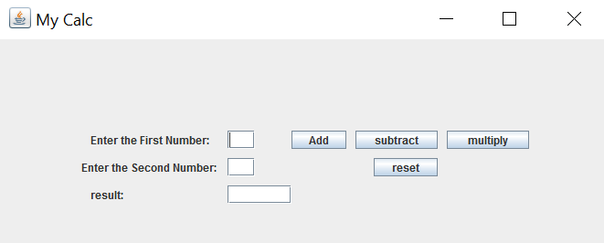

1. ***Aim of the program -***Implement a GUI application which consists of one List Box and one button. The list box will have four different color names. When the user will select a color from the list box and click on the button, the panel color will be changed to that color.

***Input*:** Select any color from the list box

***Output*:** Panel background color will be changed accordingly

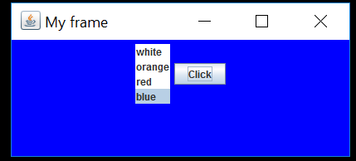

1. ***Aim of the program -***Design a GUI application which consists of three Label named as Red, Green and blue, three combo boxes which will consist the value from 0 to 255 and one button named as show output. The user will select different values from three combo boxes. When the user clicks on the button, the panel background will be changed accordingly as per the value passed in RGB format.

***Input***: select three color value(0-255) from 3 different combo box.

***Output***: The panel color will be changed accordingly

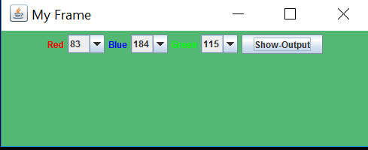

**Practice Program Sets**:-

1. ***Aim of the program -***Design a GUI Calculator as shown below using frame and action event in Java.

***Input:*** Any two number with one operator and then click on = button.

***Output***: Appropriate result will be displayed.

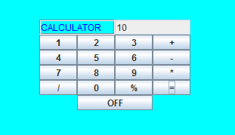

1. ***Aim of the program -***Design a GUI application as shown below which consists of two text fields and various buttons for String operations. On clicking any of the button, the corresponding operation will be performed on the entered string in the first text field and the resultant string will be displayed in the second text field.

***Input:*** Any string in the fist text field and click on any button.

***Output***: Modified string in the second field

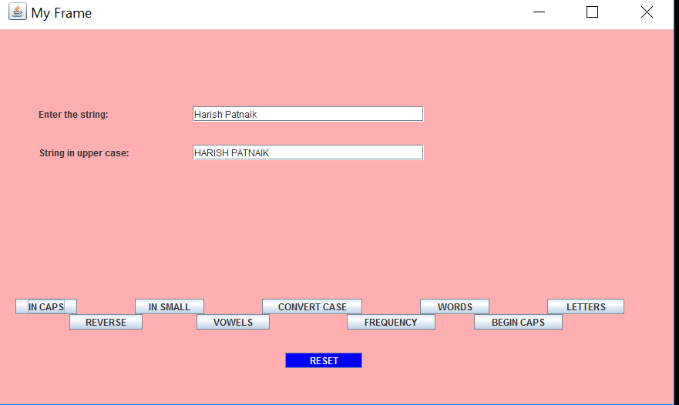

**Grading Policies:**

* *Continuous Evaluation components*

Internal Evaluation (Continuous Evaluation over the semester which includes

Quiz/Viva/Lab Record/Lab performance/Attendance etc.) : 60 Marks

* End semester evaluation

End-Term Evaluation (Sessional Exam) : 40 Marks

**Reference Materials:-**

**Reference Book:**

1. Java-The Complete Reference, Herbert Schildt, 10th Edition, McGraw Hill Education, 2014
2. Introduction to JAVA Programming, Y.Daniel Liang, 10th Edition, Pearson Education, 2007
3. Java Programming – for Core and Advanced Users, Sagayaraj, Denis, Karthik and Gajalakshmi, Universities Press.
4. Java - One Step Ahead, by Anita Seth and B L Juneja, published by Oxford University Press